# Kyrgyz Republic: Public Procurement Monitoring and Reporting Module - Detailed Case Studies

## Big data and data analytics

### Open Contracting Data Standard Transformation and Analytics

|  |  |  |  |
| --- | --- | --- | --- |
|  | **Lead Organisation**: Ministry of Finance;  European Bank for Reconstruction and Development (EBRD) |  | **Location:** theKyrgyz Republic |
|  | **Problem Statement:** The Kyrgyz Republic has made significant efforts to improve its legal framework for public sector procurement process and build a modern public procurement system. However, the data generated by the system was not standardised, making processing as well as analysis challenging and hindering data-driven decision-making. The approach to public procurement reporting was not automated and was neither efficient nor reliable. | | |
|  | **Description:** Data is retrieved from the existing electronic public procurement system, which continues to operate, and **converted into the Open Contracting Data Standard (OCDS)** and published. A **business intelligence module** works, accessing the OCDS data via an Application Programme Interface (API). This analytical and reporting module provides government procurement policymakers with **a tool to analyse and visualise procurement trends as well as tendencies**. | | |
|  | **Lessons learnt: 1.** **The complexity of the system architecture, data organisation, processes conducted** –will drive costs up, and require more effort as well as knowledge to map data and set up the business intelligence tools; **2**. **Projects should be designed in several phases**, giving time for the government to make changes on the basis of the initial business intelligence tools developed; **3.** To ensure take-up and proper use of the developed tools, a **budget for training, outreach** and **maintenance** should be included. | | |
|  | **Cost: €145 000** (main factors impacting the cost of equivalent projects are the extraction and mapping of original data to the OCDS) |  | **Impact**: Enables public procurement policymakers to make **data-driven decisions**; Provides for the automated generation of public procurement reports; Helps auditors to conduct the ex-post audit. |
|  | **Human resources:** Project implemented by **EBRD and 2 IT/consulting contractors**, providing expertise in business intelligence software, ETL and DB software development, data analysis, mapping as well as modelling. |  | **Risks:** Gaining adequate **access to public procurement data and systems** required for the project, together with the expertise to understand these systems. Potential for political blocks to the project. Poor data quality reduces the ability to build meaningful analytics. |
|  | **Other requirements:** The project requires local expertise to understand processes and legislation in public procurement sector, and to ensure completeness as well as correctness **of retrieved and** transformed data. The infrastructure for deployment should be provided by local stakeholders. | | |
|  | **Project timeline**: Apr 2018 – Jun 2019 |  | **Project status:** Fully deployed |
|  | **Email:** NiewiadE@ebrd.com |  | **Website:** [EBRD – Facilitating the participation of SMEs in public tenders Public Procurement Monitoring](https://www.ebrd.com/cs/Satellite?c=Content&cid=1395267234647&pagename=EBRD%2FContent%2FContentLayout&rendermode=live%3Fsrch-pg) |

#### Context and problem statement

The introduction of the eProcurement system as a single point of access to information on public procurement in the Kyrgyz Republic was initiated in 2012. Following the piloting phase, the online eProcurement system was officially launched in June 2014. Although significant progress has been made compared to the pre-reform period, the existing legal framework of the public procurement process focuses on high-value procurement only. As such, the existing regulation lacks competitive online procedures for small value public contracts that would guarantee sufficient access to procurement opportunities for local suppliers, especially small and medium enterprises (SMEs). The result of the situation is that there is meagre participation from SMEs in public tenders in the Kyrgyz Republic.

As demonstrated by the experience of other transition economies in the European Bank for Reconstruction and Development (the "EBRD" or the "Bank") region, there usually is low participation from local suppliers in the public procurement during the initial stages of the reforms. This is due to the local suppliers' lack of adequate knowledge on how to compete for public tenders and their inexperience in holding local authorities accountable for their procurement decisions. The lack of skills possessed by local suppliers along with complex procurement procedures and an absence of sufficient independent review and remedy procedures may easily turn public tenders into the abuse of power. From a long-term perspective, the limited response of SMEs to public tenders may lead to public authorities contracting selected suppliers at their discretion, which will, in turn, distort competition and negatively affect market development.

The Department of Public Procurement within the Kyrgyz Ministry of Finance requested EBRD's assistance with the implementation of new public procurement monitoring procedures, and the undertaking of institutional changes related to providing public access to information on public procurement decisions. Furthermore, the support was extended to establish new monitoring instruments for public procurement conducted electronically on the national electronic procurement system.

The challenges identified in the Kyrgyz Republic during the project inception stage were as follows:

* Absence of automated workflow management capability accessible to all public procurement process stakeholders.
* Limited access to the public procurement information regarding procurement procedures and public contracts.
* No standardised stored public procurement data makes a problematic delivery of reliable and accurate research results;
* Unavailable transactional data for analysis;
* Inefficient, unreliable, time-consuming approach to reporting.

#### Objectives and vision

Working with the EBRD GPA Technical Cooperation Facility, the Ministry of Finance decided to modernise its public procurement system, ensuring it can draw on the data stored within its national electronic procurement system to drive improved public procurement policies and decisions. It aimed to:

* Set a standardized official open data source for public procurement information to be used by government authorities and to enable the government functions more efficiently
* Provide improved public procurement statistics to guide decision making;
* Generate automated public procurement reports;
* Introduce Open Contracting Data Standard and open data principles to the government;

The EBRD-developed vision to achieve these objectives contains two primary points:

* Implementation of an open contracting data standard (OCDS) for the transformation of existing eProcurement data;
* Deployment of an OCDS-based reporting application which presents aggregated and detailed information on the performance of the public procurement system, as well as active and completed tenders, presented in a table format and graphics, available to professionals.

#### Technological solution and implementation

The developed solution **extracts data from the existing electronic procurement system and converts it to the OCDS standard** while allowing the electronic procurement system to continue running its processes. Once the data has been converted to the OCDS and published, **the reporting module** for public authorities has been set up, which **access this data directly through** **an API**. The public procurement **reporting module allows users to slice and dice the public procurement information, conduct research** and view the data through several different angles and filters. The overall result is the business intelligence tool to dig into and analyse the contract data.

##### Data extraction and transformation

The data drawn upon is extracted in the following ways:

* Directly from the electronic procurement system;
* Middleware (ETL) is used to extract this data, transform it into the OCDS and load it in a consolidated database. This process is shown in Figure 1.

Figure 1: OCDS Transformation and Analytics

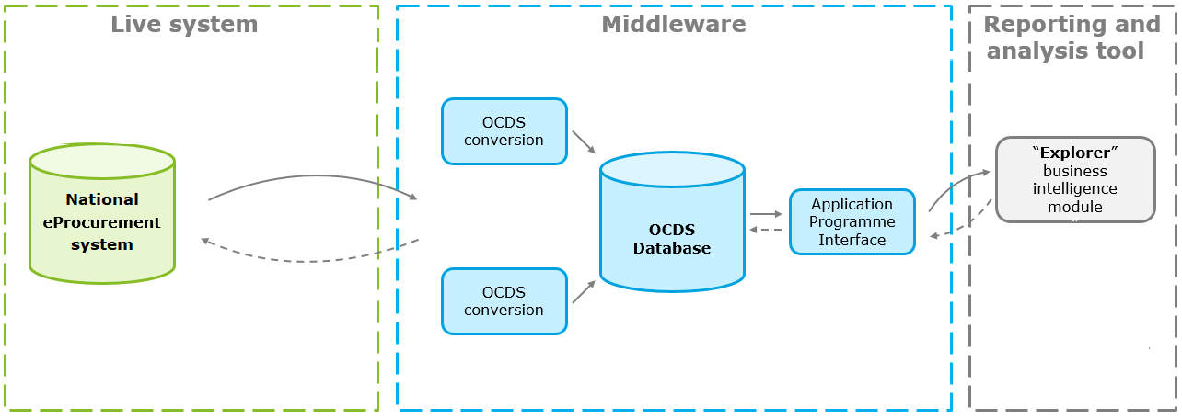

**Development of the data extraction and transformation solution**

The process of developing this data extraction and transformation system has a number of steps. First, there is a systems exploration stage. During this stage, the project team describes the processes by which the electronic procurement system operates; it conducts technical analysis of these business processes and models them using business process modelling notation. Following this, an analysis of the system database is conducted in order to understand how it operates, to assess the quality and consistency of the data, and to judge how best to extract the data. Following this, business analysis is conducted in order to map the data in the database to the OCDS standard. Once these analytical phases are complete, the project team develops the retrieval software (ETL), which extracts the data from the live electronic procurement system and load to the developed dedicated OCDS database. Finally, the data is made available for the business intelligence tool via API also developed.

##### Data analytics tool

The EBRD provides a pre-defined set of dashboards which provide different analytical angles through which the OCDS data can be viewed. These dashboards provide a breakdown between different stages, processes and markets. Aspects such as the number of complaints and challenges, purchases made by a particular public entity, rating of buyers as well as suppliers, or the number of successful procurement procedures completed can be measured.

The data to be examined at different levels of detail, ranging from an overview of the functioning of the procurement system to data on individual public procurers or tenderers. Drawing on these dashboards, the data analytics tool - "Explorer" has been provided. The "Explorer" is built for public procurement analysts within the Ministry of Finance as well as other public administrations and is intended to support their decision-making.

Figure 2 Data analytics and transparency tools

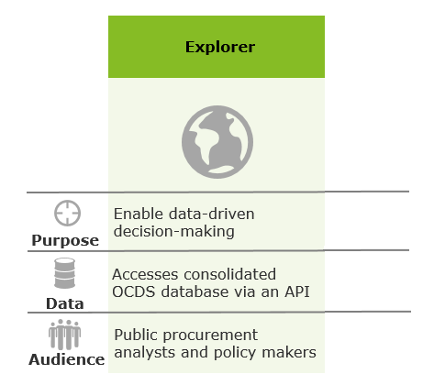

**Development of the data analytics tool**

The Ministry makes use of Qlik Business Intelligence software in order to view the "Explorer" data. The standard set of dashboards provided by the EBRD was tailored according to the needs and requests of the Ministry of Finance and according to the nature and quality of the data available. The Ministry is able to further develop its own aspects to measure and visualise according to their priorities. Using the "Explorer" application, automated reports on public procurement in the Kyrgyz Republic can also be generated.

The EBRD provided support to the public authorities for the development of the business intelligence tool. This includes not just technical support in relation to the digital tools being used, but support regarding the methodologies to use to calculate the measures of the various procurement procedures. This was done to ensure the proper alignment of the procurement processes followed and the indicators used to measure them.

#### Results and future expectations

As a result of the project, the Kyrgyz Republic now has a national-level public procurement data analytical infrastructure. This system enables a previously impossible level of visibility for procurement spending within the country and enables various types of big data analysis. In terms of the goals set for the project, the OCDS-based analytical system:

Enables the automated generation of public procurement reports – through the "Explorer" analytical tool. Provides support for public administration regarding public procurement decisions – Government employees are able to use the "Explorer" tool to analyse public procurement data and guide their procurement decisions.

The impact of the project could be increased by allocating resources and budget to training and outreach programmes to promote the use of the business intelligence tool not just within the Ministry of Finance, but in agencies and departments across the government. The tools and spending data now available could be used to guide decision-making not just for public procurement specialists but for policymakers across different policy fields. Also, it is important to encourage the government to provide access to public procurement data for the public at large.

#### Costs and requirements

Figure 3 Costs and requirements

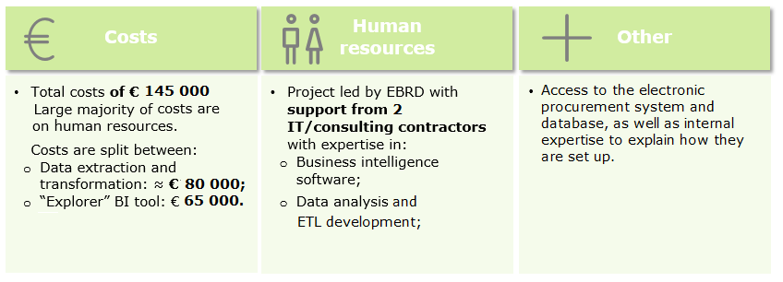

The OCDS data transformation and the analytical solution was developed for a total cost of **€145 000**. The large majority of these costs are focussed on the human resources required to first analyse the existing processes and systems, and then develop the tailored data extraction, transformation, and analytical tools needed. Any licenses that are required are relatively cheap.

The **breakdown of costs** is rough as follows:

* **Development of data extraction and transformation** – roughly **€85 000**. The main variables affecting this cost are related to the quality of the underlying eProcurement system and databases. For this case, an additional cost was incurred because of the complexity of the eProcurement system.
* **Development of the "Explorer" Business intelligence tool** – **€60 000**. The main factors influencing the cost are the underlying quality of the data, and the number of dashboards to be developed and market topics covered.

In terms of the **human resources required for the project**, the EBRD worked **with two separate consulting and technology companies** in order to develop the system. Each of these firms provided expertise in different areas, with one with specialist knowledge on the use of **Qlik and business intelligence software**, and the other with expertise in **data analysis, modelling, ETL software development**.

Other key requirements to perform the project include the **existence of digital procurement systems** in the first place. However, similar projects can be performed with a wide variety of different types and standards of such an electronic procurement system. As mentioned in the costs section above, however, the system with complex architecture and data organisation will require considerably more time and expense in order to perform the necessary data transformation and set up functioning data analytics tools. A final key requirement in order to perform such a project is to **have access to people and experts who can explain how the existing databases are set up and what the various data refer to**.

#### Risk and mitigation

At the start of the project, one of the risks identified relates directly to the point above – **access to the experts who could accurately describe the current state of the existing electronic procurement system** and database. It was not known whether this would be provided, or whether for example, the team risked being provided out-of-data or irrelevant information on the system.

Another major risk faced by the project concerned gaining **access to the electronic procurement system and data** that had been required. There was a risk of political blocks, with the electronic procurement system operator refusing to cooperate with the project.

The likelihood of poor data quality existed and could negatively impact analytics, produced by the reporting module.

#### Challenges and lessons learnt

The main challenges for the project were related to getting the **necessary support from the people and organisations** in order to access the necessary systems and data. The assessment of the legacy system and data transformation is the most challenging phase, and the completion of this task requires internal support and expertise regarding procurement processes and data.

Lessons that can be taken from the project include:

* **The complexity of the system architecture, data organisation, processes conducted** –will drive costs up, and require more effort as well as knowledge to map data and set up the business intelligence tools developed.
* **Plan the project in several phases, providing time for feedback from the Government** –Following the initial development of the business intelligence tools, the Ministry could decide to change a set of dashboards to cover additional topics which were not in the scope in the beginning. These changes affected data modelling, meant the business intelligence tools had to be themselves updated.
* The **Open Contracting Data Standard** implementation is intended to create online open data access, but it also **gives an opportunity to integrate data** on public procurement, **to improve quality of data**, to build tools for the efficient electronic procurement systems.
* **Data quality has a tremendous impact on the design**, as well as the **development** of the public procurement monitoring and reporting module, and approach to building KPIs as well as analytical angles.
* **Budget for training, outreach and maintenance should be included** –to ensure the new tools are understood and used.